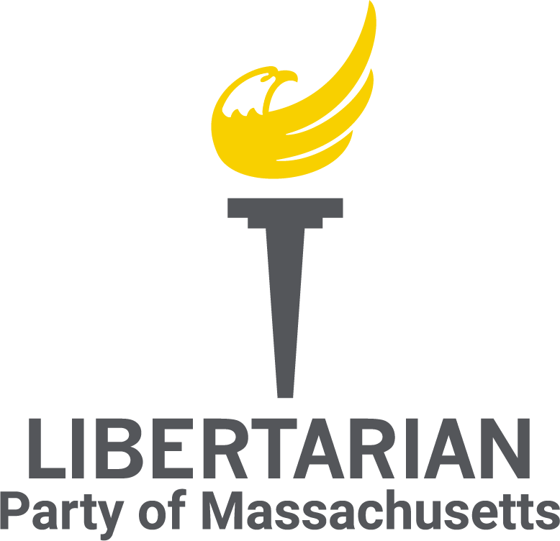

**Unified Libertarians of Massachusetts  
Meeting Minutes - April 2025**

**Call to Order**A meeting of the Unified Libertarians of Massachusetts was held at 8:00 PM on April 29, 2025 via Jitsi.

**Attendees: 9**  
Sean Kennedy  
James Parent  
Matthew Gorham  
Kimberly Sullivan  
Jason Brand  
George Calley  
Thomas R. Eddlem  
Al Ozonoff  
Ryan Sullivan

**Not in Attendance: 1**Aaron Morse

**Guest: 1**  
Brodi Elwood

**Approval of Agenda/Previous Minutes**

* Motion to approve March Minutes by James Parent, seconded by Ryan Sullivan
* Minutes for the March meeting approved via 9-0 voice vote
* ULMA convention minutes still pending from previous secretary
* Motion to approve meeting agenda by Sean Kennedy, seconded by Al Ozonoff
* Agenda approved for April meeting approved via 9-0 voice vote

**Chair’s Report**

* Defend the Guard moved to Veteran and Federal affairs
* RI LP state committee was this past Sunday, Pat Ford is chair.
  + Thomas Eddlem spoke at convention
* Potential to work with The Civil Right Coalition to build new Worcester affiliate
* Appreciate help with the town council race
* New members are steadily getting up to speed

**Vice Chair’s Report**

* Good work on Sean Kennedy getting elected to town council

**Treasurer’s Report**

**State Account:**

* Opening balance: $3,503.47
* Donations: $76.20 (Not including donations at convention deposited in April)
* Expenditures: $290.36 (FloDesk and VFW for convention)
* Ending balance: $3,289.29

**Federal Account:**

* Opening balance: $19,373.84
* KVF Transfers In: $28,170.00
* KVF Transfers Out to LNC: $25,353.00
* Expenditures: $69.00 (wire fee)
* Ending balance: $22,021.84
* Net balance as of 4/29/25: $24,285.86 (less applicable fees)
* The Kennedy Victory Fund had its last transfer in April, so no further deposits expected
* The transition to the new treasurer, Matt Gorham is ongoing. Matt received approval from his employer to take on the role in the last week. Tom Eddlem will file the April state report with him, is filing an amended FEC Form 1, and is transferring other responsibilities to Matt.
* FEC form 1 turned in
* Matt G to look into taking OCPF Treasurer’s class

**Communications Director’s Report**

* Social media; X, Facebook
  + Schedule for posting
  + Post about Libertarian events
  + Focus more on local events/elections

**Membership Director’s Report**

* Postcard design on hold
  + Waiting on tax exempt status, information form IRS
  + $1000.00 mailing budget
* Follow up o lapsed memberships
* Work on emails to send out

**Political Director’s Report**

* Focusing on affiliates
* Meeting regarding postcards to people in 10 mile radius if next meeting

**IT Director’s Report**

* Made some edits to the Election Results post
* Put the new state committee names on the website
* Posted the new bylaws to the website
* Emailed the 10th amendment center blog post to my state senator and rep and to the MAPA guys
* Received the keys for our webmail
* Looks like we’ll need a new Jitsi link going forward

**Old Business**

**Postcards:**

* On hold, waiting for tax exempt status, IRS access

**New Business**

**New Committees:**

* Plan to vote on at next meeting
* More involvement with general membership
* Defend the Guard Committee
  + More people to attend DTG training
* Membership Growth Committee
* Legislative Action Committee
  + ‘Think tank” via signal chat
* Contact for Coalition list-Worcester County

**X account up for renewal in May,**

* price increased x2, discussed dropping down a tier

**Porcfest**

* Discussed having banner up at Sean’s campsite
* Discussed having a table with ULMA, SSLP, LP merch
  + Pens, stickers
  + QR code

**Announcements**

* Next meeting Thursday May 15th, 2025 via Jitsi

**Adjournment**

* Jason Brand motioned to close meeting, seconded by James Parent
* Meeting adjourned at 9:15PM, approved via 9-0 voice vote

**Kimberly Sullivan**Secretary  
Date of Approval: May 15th, 2025