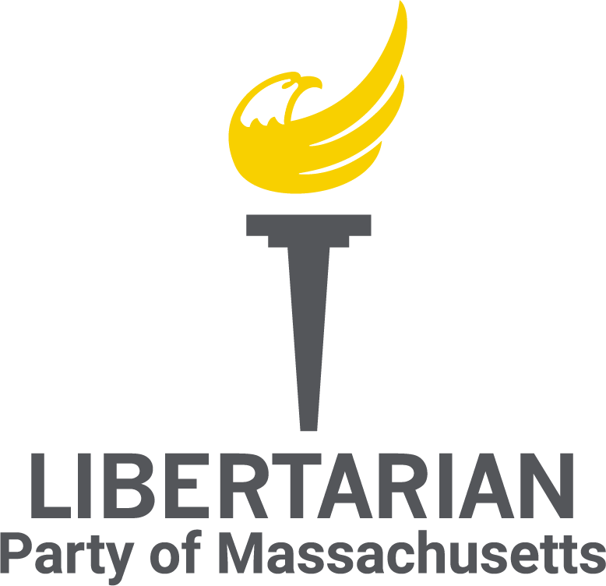

**Unified Libertarians of Massachusetts  
Meeting Minutes - May 2025**

**Call to Order**A meeting of the Unified Libertarians of Massachusetts was held at 8:00 PM on 5/15/25 via Jitsi.

**Attendees:**  
Sean Kennedy  
James Parent  
Kimberly Sullivan  
Jason Brand  
George Calley  
Thomas R. Eddlem  
Ryan Sullivan  
Aaron Morse

**Not in Attendance:**Al Ozonoff  
Matt Gorham

**Approval of Agenda/Previous Minutes**

* Motion to approve meeting agenda by Sean Kennedy, seconded by George Calley
* Agenda approved for May meeting via voice vote (8-0)
* Motion to approve April Minutes by James Parent, seconded by Thomas Eddlem
* Minutes for the March meeting approved via voice vote (8-0)
  + Still awaiting March 2025 convention minutes from previous ULMA secretary Rebecca Lau
    - Kimberly Sullivan to reach out in attempt to obtain

**Chair’s Report**

* Sent annual Chair report into Pat Ford

**Vice Chair’s Report**

* Nothing new to report

**Treasurer’s Report**

* **State account:** 
  + **Beginning Balance:** $3,289.29
  + **Donations:** $338.20
  + **Expenses:** $40.38 (FloDesk)
  + **Ending Balance:** $3,587.11
* **Federal account:** 
  + **Beginning Balance:** $22,021.84
  + **KVF Incoming:** $28,806.91
  + **KVF Outgoing:** $22,326.19
  + **Donations:** $100.00 (Pat Ford table fee for convention)**$**
  + **Expenses:** $42.00 wire fee, $200 in speakers fees for convention, $75 for speakers' meals for post-convention
  + **Ending Balance:** $24,285.56
* Reminder: The Kennedy Victory Fund had its last transfer in April, so we won't be getting any more money for our federal fund from this arrangement.
* All of the convention expenses and contributions have been logged, and all the debts (speaker fees) paid.
* The transition to the new treasurer, Matt Gorham is ongoing. Tom Eddlem filed the April state report and an amended FEC Form 1, and is transferring other responsibilities to Matt.

**Communications Director’s Report (Stopped here)**

* Get messaging aligned

**Membership Director’s Report**

* Not present

**Political Director’s Report**

* Discussed creating new affiliates

**IT Director’s Report**

* Set up email forwarding for a few State Committee members
* Posted March minutes to website
* Established a new Jitsi Meet for future meetings

**Old Business**

**Postcards:**

* To be discussed in Signal chat

**X account:**

* Sean Kennedy motioned to pay $44.61 for X basic (in perpetuity). Seconded by James Parent. Discussion regarding motion led to Sean Kennedy making a motion to amend the above mentioned motion to use X premium for $122.19 for one year, seconded by Ryan Sullivan. Sean Kennedy called for a vote seconded by James Parent, motion passed via 8-0 voice vote.

**PorcFest**

* Banner
* Email Ballot; Kim Sullivan and James Parent to discuss via signal

**New Business**

**Committees:**

* Motion by Sean Kennedy to establish a Defend the Guard Committee. Committee to have 5 members to be selected by ULMA chair. Committee to elect Chair from within. Seconded by Ryan Sullivan. Sean Kennedy called for a vote, seconded by Ryan Sullivan. Motion passed via 8-0 voice vote.
* Motion by Sean Kennedy to establish a Membership Growth Committee. Committee to have a minimum of 5 members to be selected by ULMA chair. Committee to elect Chair from within. Seconded by Thomas Eddlem. Sean Kennedy called for a vote, seconded by Thomas Eddlem. Motion passed via 8-0 voice vote.
* Motion by Sean Kennedy to establish a Legislative Committee. Committee to have a minimum of 5 members to be selected by ULMA chair. Committee to elect Chair from within. Seconded by Thomas Eddlem. Sean Kennedy called for a vote, seonded by Thomas Edlem, Motion passed via 8-0 voice vote.

**Announcements**

* Protest Electro Shock Therapy at JRC-Citizens Commission on Human Rights
* Next Meeting on June 26th, 2025, via Jitsi

**Adjournment**

* Motion to adjourn by Sean Kennedy at 8:50PM, seconded by Ryan Sullivan. Approved by 8-0 voice vote

**Kimberly Sullivan**Secretary  
Date of Approval: __________